ABSTRACT
The Student Notes Sharing System is a web-based application developed to help students upload, manage, and share academic notes in a structured manner. It provides a centralized platform where students can easily access study materials of different subjects.
The system includes secure user registration and login functionality and supports uploading multiple file formats such as PDF and images. This project focuses on improving collaboration among students, increasing availability of learning resources, and making note sharing more organized and efficient.
This system is designed for student use only and does not include an admin panel. All features such as upload, edit, and delete are handled by registered users.

ACKNOWLEDGEMENTS
I would like to express my heartfelt appreciation to my instructor Abin Shrestha for his valuable guidance and continuous support throughout the development of this project.
I am also thankful to my friends and classmates who helped me in testing the system and provided useful feedback for improvement. Their encouragement and suggestions played an important role in completing this project successfully.

Table of contents
ABBREVIATIONS…………………………………………………….4
LIST OF FIGURES…………………………………………………….5
CHAPTER 1: INTRODUCTION………………………………………6
CHAPTER 2: SYSTEM ANALYSIS & DESIGN…………………….7
CHAPTER 3: IMPLEMENTATION………………………………….10
CHAPTER 4: TESTING & VALIDATION………………………........15
CHAPTER 5: RESULTS & DISCUSSION………………………........16
CHAPTER 6: CONCLUSION & FUTURE ENHANCEMENTS……..19
APPENDICES…………………………………………………………20
REFERENCIES……………………………………………………….27

ABBREVIATIONS
PHP | Hypertext Preprocessor
SQL/MYSQL | Structured Query Language
CRUD | Create, Read, Update, Delete
UI | User Interface
UX | User Experience

CHAPTER 1 : INTRODUCTION
Background
In modern education, students depend on digital resources for learning. However, sharing notes through traditional methods such as messaging apps or printed copies is often disorganized and inefficient. A centralized digital system is necessary to manage and distribute academic materials effectively.
The Student Notes Sharing System is designed to provide an organized platform where students can upload and share notes easily. It ensures quick access to study materials and promotes collaborative learning.
Problem Statement
Existing methods of note sharing such as social media or manual exchange create confusion and make it difficult to manage resources properly. Files may get lost, duplicated, or become difficult to find. Therefore, a structured web-based system is required to store and manage notes securely.
Objectives:
- Develop a web-based platform for students to share notes.
- Implement secure user registration and login system.
- Support multiple file formats like PDF and images.
- Provide user-friendly interface for managing notes.
- Ensure proper file storage and management.

Scope & Limitations:
Scope:
- Users can register and login into the system.
- Users can upload, view, edit, and delete their notes.
- System is accessible using web browser on desktop or mobile.
- Each user manages only their own uploaded notes.
Limitations:
- No admin panel available.
- No offline access.
- Limited file upload size.
- Advanced search feature not included.

CHAPTER 2: SYSTEM ANALYSIS & DESIGN

Requirement Analysis

Functional Requirements
- User registration and login system.
- Separate dashboard for admin and users.
- Upload, edit, and delete notes.
- View and download shared notes.
- Secure session management.

Non-Functional Requirements
- Security: Password encryption and input validation.
- Usability: Easy navigation and responsive design.
- Performance: Fast uploading and loading of files.

System Flowchart

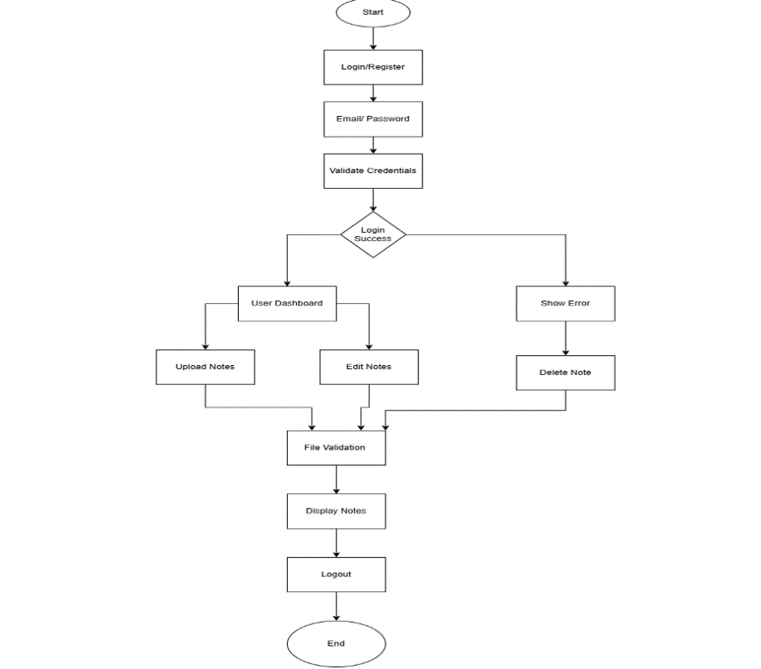

Figure 1: System Architecture

CHAPTER 3: IMPLEMENTATION

Tools and Technologies Used

PHP

MySQL

HTML, CSS, JavaScript

XAMPP Server

System Modules

1. Header Module
Displays navigation menu and links based on login status.

2. User Authentication
Users can register and login securely. Sessions are used to maintain login status.

3. Dashboard
Shows uploaded notes in an organized layout. Users can manage their notes easily.

4. Upload Notes
Users can upload notes with title, subject, description, and file. File validation and size checking are implemented.

5. View Notes
Displays full details of selected note with download option.

6. Edit & Delete
Users can update or remove their notes. Admin has permission to manage all notes.
Screenshots with Explanations:
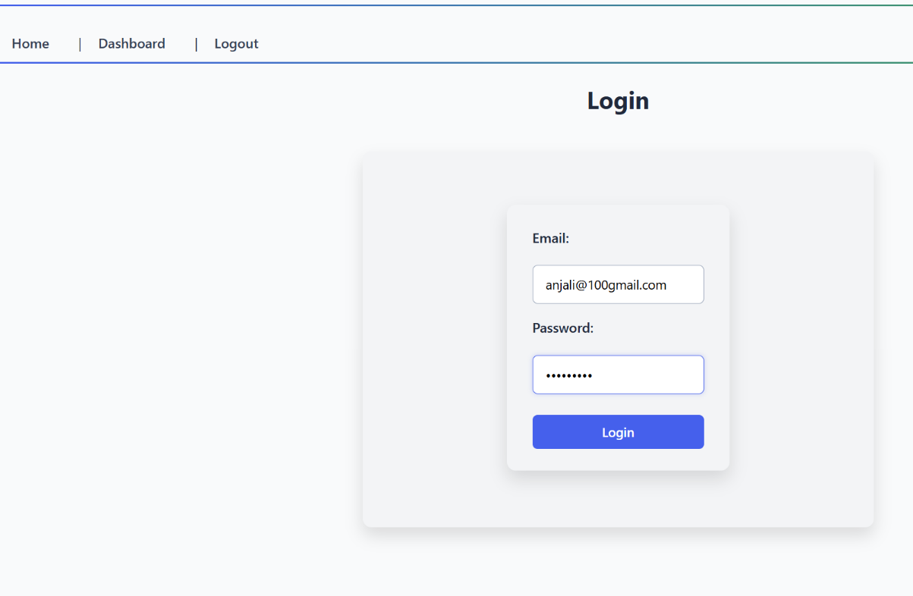

Fig 1: Login page

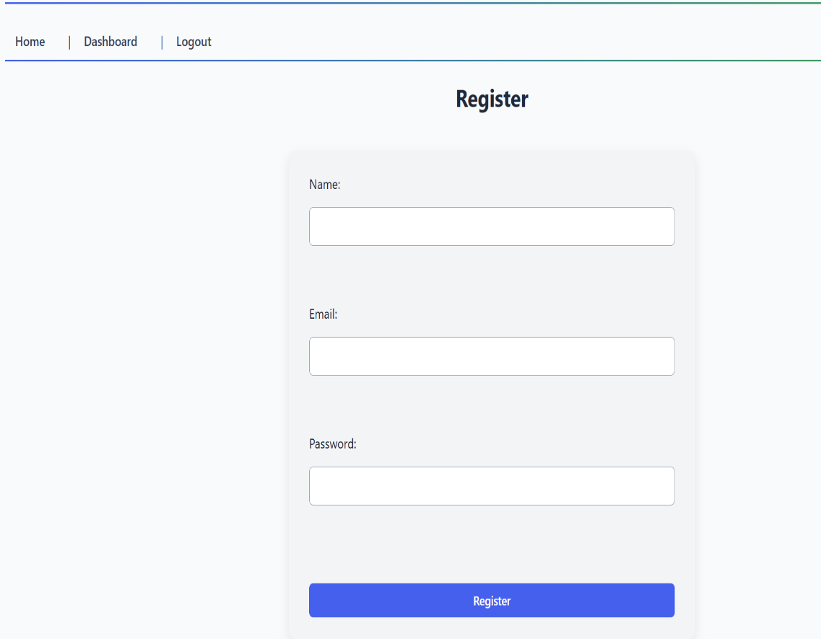
The login page allows registered users to access the system using their email and password.
It verifies user credentials from the database securely. After successful login, users are redirected to their dashboard.

Fig 2: Register page
The register page enables new users to create an account in the system.
Users must provide basic details like name, email, and password.
After successful registration, they can login and use the system features.
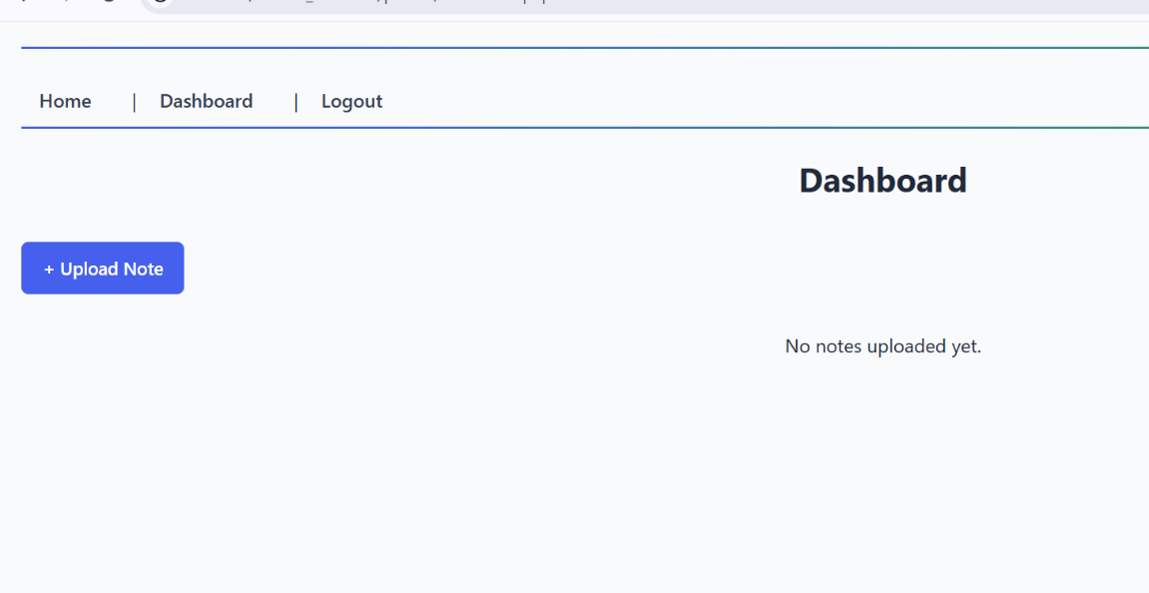

Fig 3:Dashbord page
The dashboard displays all uploaded notes of the logged-in user.
Users can view, edit, or delete their notes from this page.
It acts as the main control panel of the system.

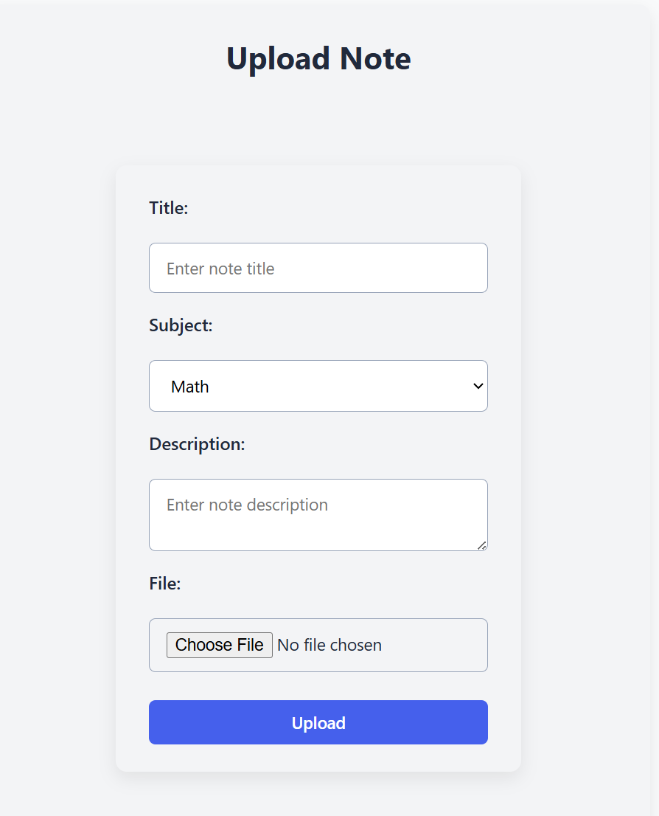

Fig 4: Upload Note page

The upload page allows users to add new academic notes to the system.
Users enter title, subject, description, and upload files like PDF or images.
After submission, the note is stored and shown on the dashboard.

CHAPTER 4: TESTING & VALIDATION
Test Cases:
Test Case | Input | Expected Output | Status
Login | Valid credentials | Redirect to dashboard | Pass
Login | Invalid credentials | Error message | Pass
Upload | PDF file | Uploaded successfully | Pass
Upload | File > limit | Error message | Pass
Edit | Update title | Updated successfully | Pass
Delete | Click delete | Note removed | Pass

Security Measures
- Password hashing for secure storage.
- Session management for authentication.
- Input validation to prevent SQL injection.

Error Handling
- Proper error messages displayed for invalid actions.
- File upload errors handled carefully.

CHAPTER 5: RESULTS & DISCUSSION
The system was successfully developed and tested. All major features such as user authentication, file upload, editing, and deletion are functioning properly.
The dashboard provides a clear view of uploaded notes. Users can easily access and manage their files. Admin has full control over the system. The system is responsive and works well on different screen sizes.
Screenshots of Working System:
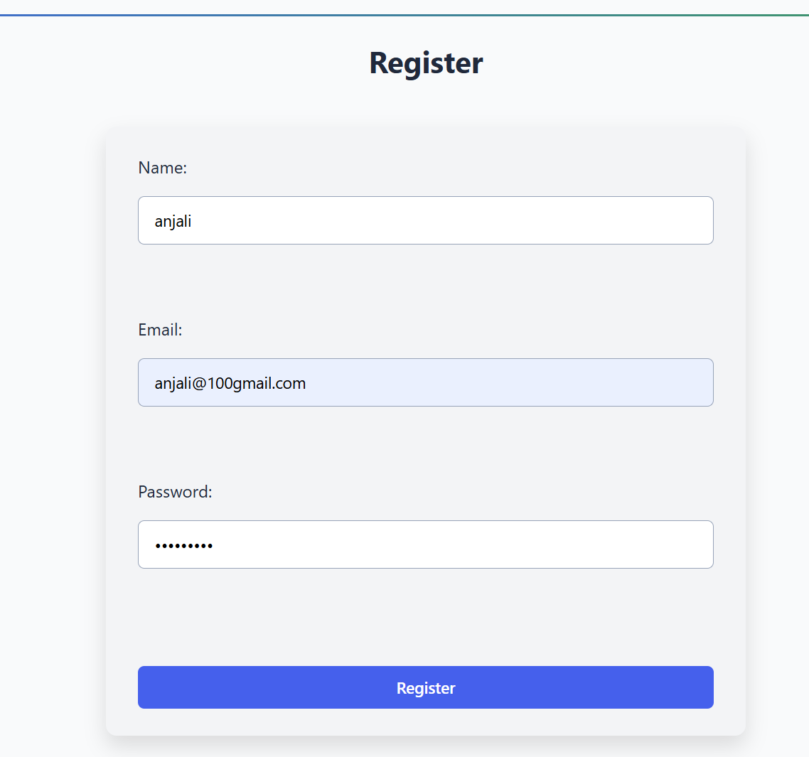

Fig 1: Register page
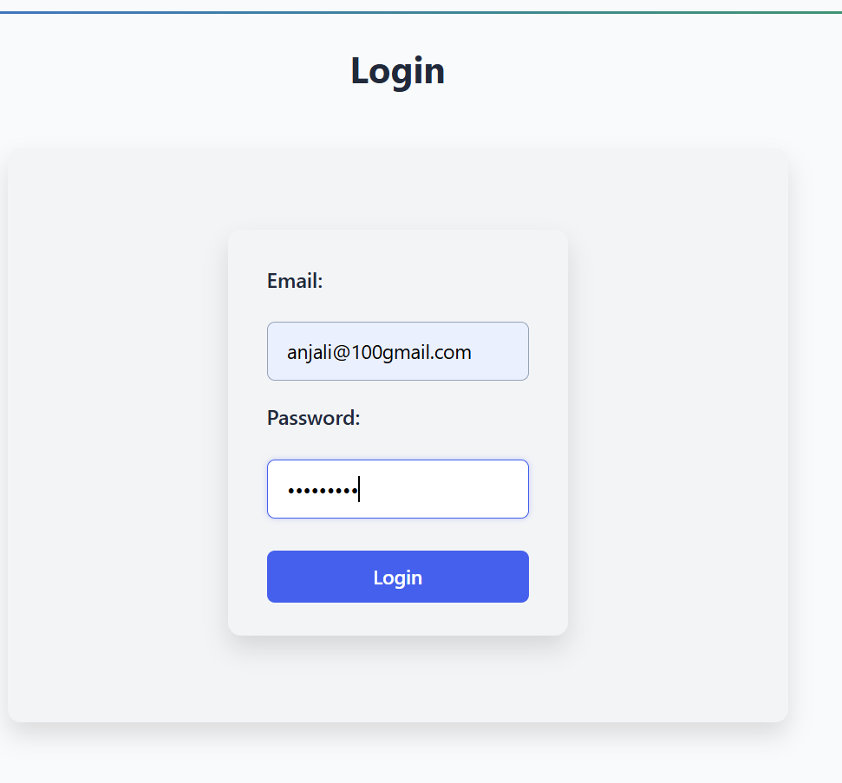

Fig 2: Login page
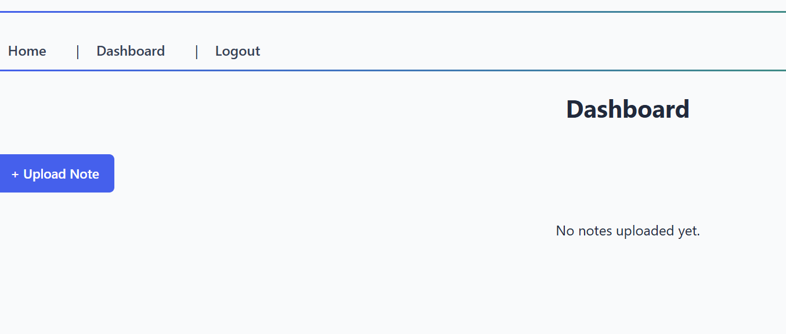

Fig 3: Dashboard page
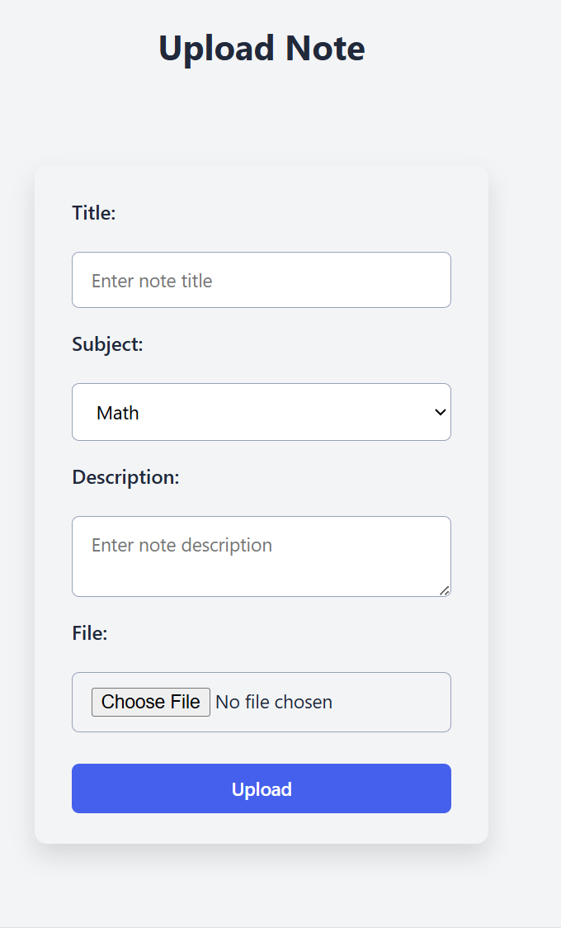

Fig4: Upload Note page

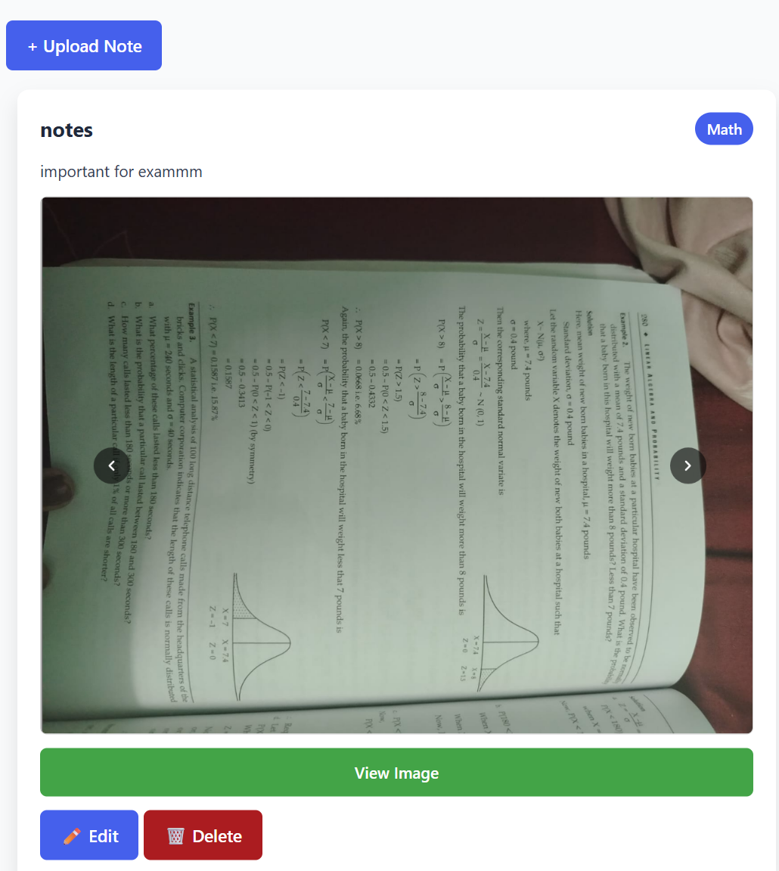

Fig5: View Note page
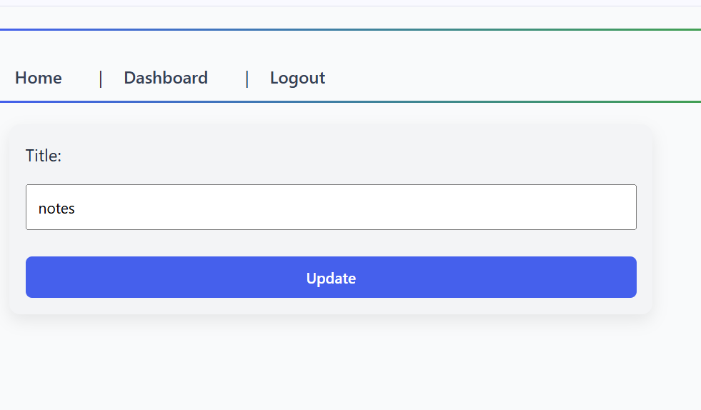
Fig6: Edit page
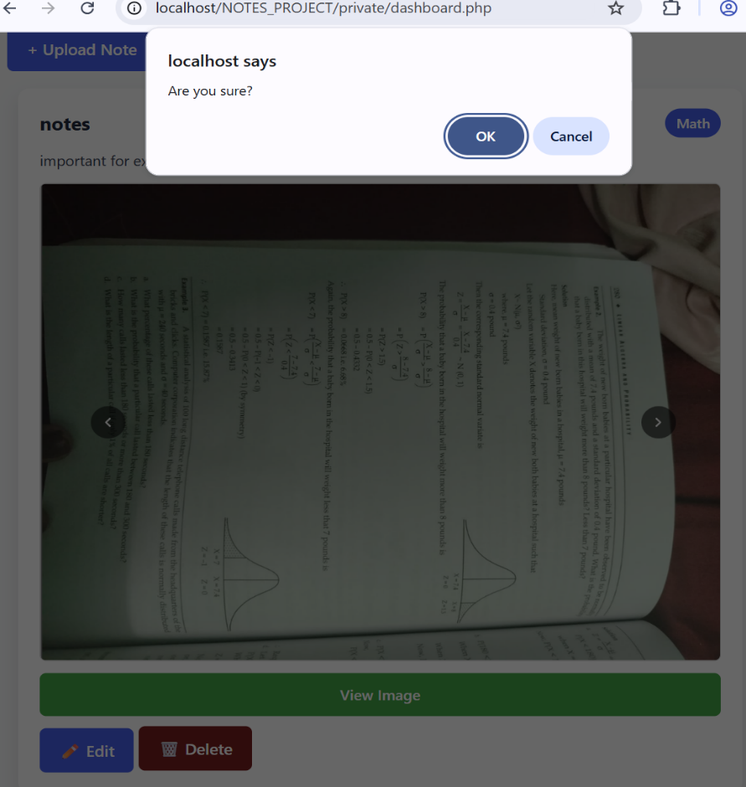

Fig7: Delete page
CHAPTER 6: CONCLUSION & FUTURE ENHANCEMENTS

Conclusion
The Student Notes Sharing System provides an efficient and reliable platform for managing academic notes. It simplifies the process of sharing study materials and ensures secure storage of files. The system fulfills its main objectives and improves collaboration among students.

Future Enhancements
- Add search and filter features for notes.
- Enable comments and ratings for notes.
- Provide notification for new uploads.
- Allow larger file uploads and multiple file support.
- Add analytics for most downloaded notes.

REFERENCES
W3Schools, PHP Tutorial, Available at: https://www.w3schools.com/php/
MySQL Documentation, MySQL Reference Manual, Available at: https://dev.mysql.com/doc/
XAMPP Official Website, Apache, MySQL, PHP Stack, Available at: https://www.apachefriends.org/

